
SEMESTER 1

Autumn 2020 Examination

CS320

Computer Networks

Dr M. Huggard, Dr J. Timoney, Dr. B. Hennelly

Time allowed: 2 hours

All questions carry equal marks

Instructions

 | Yes | No
Log Books Allowed |  | X
Formula Tables Allowed |  | X
Other Allowed (enter details) |  | X

All questions carry equal marks.

You must answer Question 1 and any three other questions.
Your mark will be based on Question 1 and your best three answers from the remaining questions.

1. |  | Short Questions  - Suppose all of the network sources send data at a constant bit rate. Would packet-switching or circuit-switching be more desirable in this case? Why? (Answer: circuit-switching is more desirable here as there are no statistical multiplexing gains to be had, and by using circuits, each connection will get a constant amount of bandwidth that matched its CBR rate. On the other hand, circuit-switching has more overhead in terms of signaling, so there is an argument that packet-switching is better here since there is no call setup overhead. I’ll take either answer). Now suppose that all of the network sources are bursty – that they only occasionally have data to send. Would packet-switching or circuit switching be more desirable in this case? Why? (Answer: Packet-switching is better here because there are statistical multiplexing gains – when a source does not have data to send, it will not be allocated bandwidth (that would be idle). Hence this bandwidth is available for use by other sources).  - Suppose there is exactly one packet switch between a sending host and a receiving host. The transmission rates between the sending host and the switch and between the switch and the receiving host are both R = 1.5Mbs. Assuming that the switch uses store-and-forward packet switching, what is the total end-to-end delay to send a packet of length L=6Mbytes? (Ignore queuing, propagation delay, and processing delay.) At time t₀ the sending host begins to transmit. At time t₁ = L/R, the sending host completes transmission and the entire packet is received at the router (no propagation delay). Because the router has the entire packet at time t₁, it can begin to transmit the packet to the receiving host at time t₁. At time t₂ = t₁ + L/R, the router completes transmission and the entire packet is received at the receiving host (again, no propagation delay). Thus, the end-to-end delay is 2L/R.  - What is the purpose of DNS and where are the records stored? why is it necessary? Provides a translation between host names and IP address. It is an essential component of the internet; records are stored in a distribute hierarchical database.  - What is the purpose of the HTTP “COOKIE:” field? Are the values in the HTTP message’s cookie field stored at the client or server or both? Explain briefly. Answer: a cookie can be used to maintain state between HTTP transactions. For example, if a user uses the same cookie in its HTTP requests whenever dealing with a given ecommerce site, that site can track all interactions with the user associated with that cookie. Both the client and server store the cookie value.  - Explain the difference between TCPs congestion control and flow control? Which of these two services does UDP offer? Congestion control is a reaction to congestion whereby TCP reduces the amount of traffic it sends at one time (number of unacknowledged segmentsat one time); it does this by halving cwnd. Flow control is a similar reduction in segments sent in order to match the available buffer space in the receiver. Space is advertised in the ACK.  - Suppose a web server has 1000 ongoing TCP connections. How many server-side welcoming sockets are used? How many server-side port numbers are used? Briefly (two sentences at most each) explain your answer. 1 welcoming socket, 1000 unique sockets for each client. One port number  - Describe how packet loss can occur at output ports. Can this loss be prevented by increasing the switch fabric speed? Assuming input and output line speeds are the same, packet loss can still occur if the rate at which packets arrive to a single output port exceeds the line speed. If this rate mismatch persists, the queues will get larger and larger and eventually overflow the output port buffers, causing packet loss. Note that increasing switch fabric speed cannot prevent this problem from occurring.  - What is the difference between a forwarding table that we encountered in destination-based forwarding and OpenFlow’s flow table?  Each entry in the forwarding table of a destination-based forwarding contains only an IP header field value and the outgoing link interface to which a packet (that matches the IP header field value) is to be forwarded. Each entry of the flow table in OpenFlow includes a set of header field values to which an incoming packet will be matched, a set of counters that are updated as packets are matched to flow table entries, and a set of actions to be taken when a packet matches a flow table entry.  - Explain the difference between an IP address and a physical address. Why might a host need both? IP is an internet address designed to work with network layer protocols inclugind inter and intra network protocols. It is hierarchical and often dynamic. The Mac address is flat and is designed to be permanent. It works with Link layer protocols such as ethernet of 9802.11. A network interface will often have both.  - Suppose one is interested in bounding the amount of time it takes to send a packet from one host to another on the network. Would you recommend CSMA or token passing for such a network? With CSMA there in no bound on the amount of time it might take for a node to successfully send a packet. In token passing, the delay is bounded by the amount of time it takes for everyone to get their turn. Thus, token passing is preferred.

2. |  | Persistent/Non-persistent HTTP  Assume you request a webpage consisting of one document and five images. The document size is 1 kbyte, all images have the same size of 50 kbytes, the download rate is 1 Mbps, and the RTT is 100 ms.  - How long does it take to obtain the whole webpage under the following conditions? (Assume no DNS name query is needed and the impact of the request line and the headers in the HTTP messages is negligible).  - Nonpersistent HTTP with serial connections.  - Nonpersistent HTTP with two parallel connections.  - Nonpersistent HTTP with six parallel connections.  - Persistent HTTP with one connection.  Answer:  (i)  Nonpersistent HTTP with serial connections.  Answer:  a separate TCP connection will have to be made for each of the 6 objects, in series  =6*2RTT + + t_file + 5*t_image  =12RTT + L bits/R bps  =12x0.1s + + (8x1,000 + 5x8x50,000)/1,000,000  =1.2s + 2.008s  =3.208s  (ii)  Firstly we just have the initial URL. We use that to get the document, which also contains the URLs for the images = 2RTT + t_document  Each of the two parallel connections will now make TCP connections back to back.  The first connection will request 2 images, and the second will request the other 3 images.  The latter will take longer, so it defines the total transmission delay in terms of RTTs  =3*2RTT  We also have to send all the images  Total = 8RTT + t_document + 5*t_image (L bits/R bps)  =8x0.1s + (8x1,000bits + 5x8x50,000bits)/1,000,000bits/s  =0.8s + (2,008,000 / 1,000,000)  =0.8s + 2.008s  =2.808s  (iii)  Firstly we just have the initial URL. We use that to get the document, which also contains the URLs for the images = 2RTT + t_document  Each of the parallel connections will have to make 1 TCP connection. We can only use 5 of the 6. = 2RTT  We also have to download the images  total=4RTT + 5*t_image + t_document  =4x0.1s + (8x1,000 + 5*8x50,000)/1,000,000  =0.4s + 2,008,000/1,000,000s  =0.4s + 2.008s  = 2.408s  (iv)  Persistent connection uses one TCP connection which stays alive for the duration of the session.  1 RTT to initiate TCP connection  1 RTT to request the document  And when we have the document, we have the URLs  So all the objects can be requested at the same time  Total=3RTT + t_document+ 5*t_image  =3RTT + L bits/R bps  =3x0.1s + (8x1,000 + 5x8x50,000)/1,000,000  =0.3s + 2,008,000 / 1,000,000  =0.3s + 2.008s  =2.308s  - Generalize the results obtained for the two scenarios (i) and (iv) above to a document size of L_{d} bytes, N images with size of L_{i} bytes (for 0 <=i<N), a rate of R byte/s and a round trip time of RTT.  Answer:  Non-persistent:  =2*RTT needed for each individual GET request  Each file is requested in serial  =(N+1)*2*RTT + (L_d + N*L_i)/R  Persistent:  1 RTT to initiate TCP connection, 1 RTT to get document, 1 RTT to get images  =3*RTT + t_document + N*t_image  =3*RTT + (L_d + N*L_i)/R | [25 marks]  [5 marks]  [5 marks]  [5 marks]  [5 marks]  [5 marks]

3. |  | Reliable Data Transfer Protocol  Consider two network entities, A and B, which are connected by a perfect bi-directional channel (i.e., any message sent will be received correctly; the channel will not corrupt, lose, or re-order packets). A and B are to deliver data messages to each other in an alternating manner: First, A must deliver a message to B, then B must deliver a message to A, then A must deliver a message to B and so on. If an entity is in a state where it should not attempt to deliver a message to the other side, and there is an event like rdt_send(data) call from above that attempts to pass data down for transmission to the other side, this call from above can simply be ignored with a call to rdt_unable_to_send(data), which informs the higher layer that it is currently not able to send data. [Note: This simplifying assumption is made so you don’t have to worry about buffering data.] Draw a FSM specification for this protocol (one FSM for A, and one FSM for B!). Note that you do not have to worry about a reliability mechanism here; the main point of this question is to create a FSM specification that reflects the synchronized behavior of the two entities. You should use the following events and actions that have the same meaning as the rdt protocols we developed in the course: rdt_send(data), packet = make_pkt(data),udt_ send(packet), rdt_rcv(packet),extract (packet,data), deliver_data(data). Make sure your protocol reflects the strict alternation of sending between A and B. Also, make sure to indicate the initial states for A and B in your FSM descriptions.  Answer:  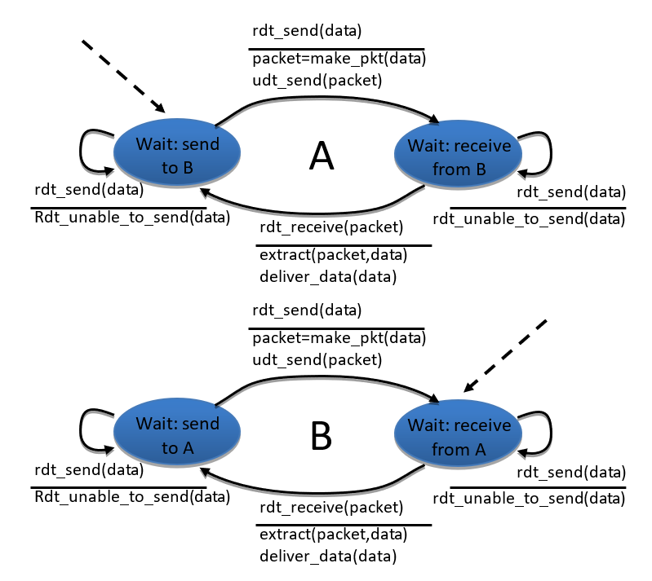 | [25 marks]

4. |  | Sliding window protocols  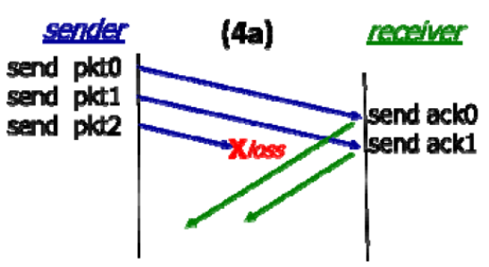  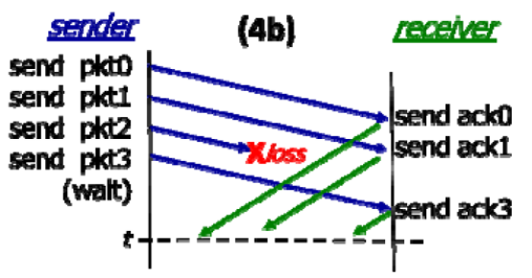  - Consider the sliding window protocol in Figure (4a). Does this figure indicate that Go-Back-N is being used, Selective Repeat is being used, or there is not enough information to tell? Explain your answer briefly. Answer: there is not enough information to tell, since both GBN and SR will individually ACK each of the first two messages as they are received correction.  - Consider the sliding window protocol Figure (4b). Does this figure indicate that Go-Back-N is being used, Selective Repeat is being used, or there is not enough information to tell? Explain your answer briefly. Answer: This must be the SR protocol since pkt 3 is acked even though pkt 2 was lost. GBN uses cumulative ACKs and so would not generate an ACK 3 if pkt 2 was missing.  - Consider Figure (4b) again. Suppose the sender and receiver windows are of size N = 4 and suppose the sequence number space goes from 0 to 15. Show the position of the sender and receiver windows over this sequence number space at time t (the horizontal dashed line). Answer:  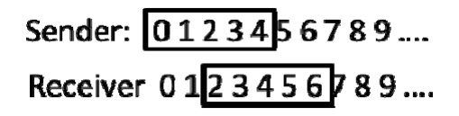  - Give a list of all possible future events at the sender resulting from the ACKs currently propagating from receiver to sender at time t. For each of these events, indicate the action take at the sender (only).  - If the next event is ACK0 received, then the sender will advance the window and send pkt4  - If the next event is ACK1 received (ACK 0 is lost), then the sender will note that 1 has been ACKed but will not advance the window and will not send anything.  - If the next event is ACK2 received (ACK 0 and ACK 1 are lost), then the sender will note that 2 has been ACKed but will not advance the window and will not send anything.  - If ACK0, ACK1, and ACK3 are lost the next event will be a timeout, and since no ACKs have been received the sender will resend pkt0, pkt1, pkt 2 and pkt3.  - Suppose that it take 1 ms to send a packet, with a 10 ms one-way propagation delay between the sender and receiver. The sliding windows size is again N = 4. What is the channel/link utilization?  Answer: the utilization is 4/(1+20) or 0.19. | [25 marks]  [4 marks]  [4 marks]  [4 marks]  [8 marks]  [5 marks]

5 |  | Distance Vector Routing  Consider the network shown in the figure below  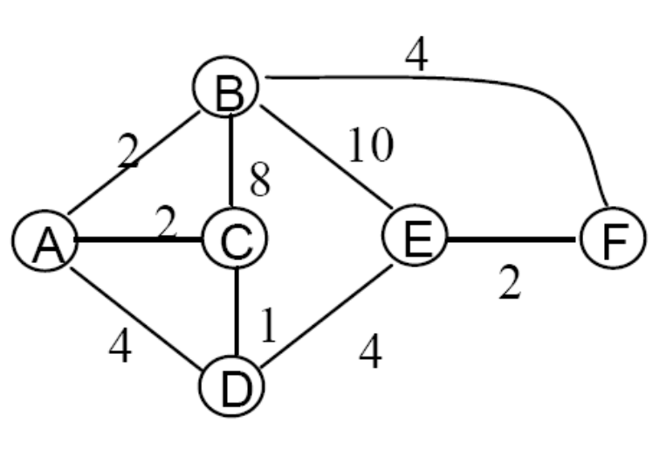  - Show the operation of Dijkstra’s (Link State) algorithm for computing the least cost path from B to all destinations.  - From these results, show the least cost path from B to D, and briefly describe (in a sentence) how you got that answer from your work in part a).  Answer The shortest from B to D can be found by BACD, this is found from the table as follows: last entry in D’s column gives C as predecessor of D. Last entry in C column gives A is predecessor of C. Last entry in A’s column gives B (the source) as predecessor of A. So the reverse path is DCAB, and the forward path is BACD.  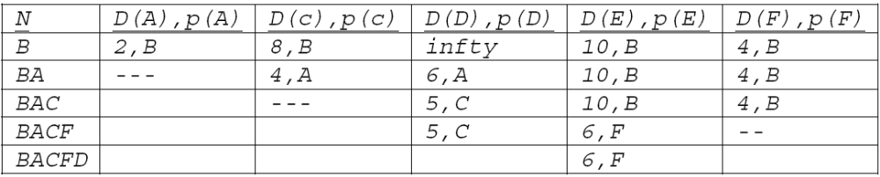  - Define the Bellman-Ford equation.  - Consider now the ring network shown below. What are distance vectors in nodes B, and C? Note: you do not have to run the distance vector algorithm; you should be able to compute distance vectors by inspection.  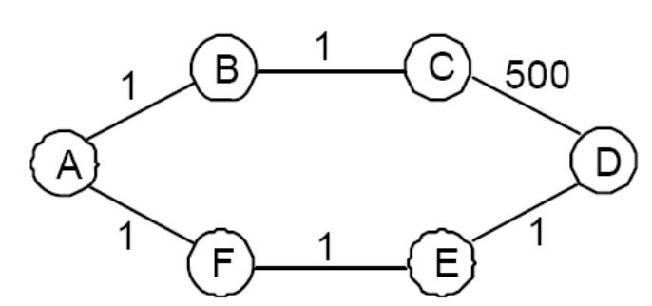  Answer: Following notation from class, let dx(y) equal the min cost from x to y. dB(A)=1, dB(C)=1, dB(D)=4, dB(E)=3, dB(F)=2. dC(A)=2, dC(B)=1, dC(D)=5, dC(E)=4, dC(F)=3.6  - Now suppose that the only destination in this new network in the figure above is A (i.e., we will only consider routing table entries here for A). Suppose that link from A to B fails (its cost goes to infinity) Once the failure is detected, approximately how many messages will be exchanged by all nodes by the distance vector algorithm until no more messages are exchanged? Justify your answer in one or two sentences. Note: you do not have to run the distance vector algorithm (it would take you hours); also, your answer need not be exactly correct, it can be off by a bit. This question is trying to get at the essence of the count-to-infinity problem.  Answer: F, E and D all route to A via the lower part of the loop before the failure and so their paths will be unchanged. B will initially say to C “my cost is now 3” – the cost from B to C plus C’s cost to A (which is 2). C will then say to B, “my cost is now 4” – the cost from C to B plus B’s just-advertised cost to A (which was 3). B will then say to C “my cost is now 5” … and so on. (This is the count to infinity problem). Thus, approximately 500 messages will be required until finally C will route through D. (any answer around 500 is fine). | [25 marks]  [8 marks]  [3 marks]  [3 marks]  [5 marks]  [6 marks]

6. |  | Link and Network Layer operating  Consider the network shown below.  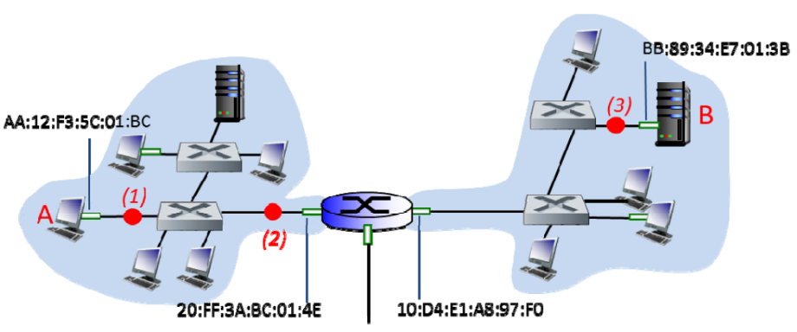  - Assign IP address ranges to the subnets containing hosts A and B, and assign IP addresses in these ranges to hosts A and B. (You don’t have to assign IP addresses to any hosts except A and B, but you do need to specify the address range being used by each subnet). Your subnet addressings should use the smallest amount of address space possible.  Answer: Because there are less than eight but more than 4 nodes in each subnet, we’ll need three address bits for each subnet. So let’s assign the left subnet XX.YY.ZZ.xxxx0***/29, where the XX.YY.ZZ are 8 bit numbers. Each x is a bit and the three *’s correspond to the three address bits for this network. For the right subnet, well use XX.YY.ZZ.xxxx1***/29. A will have an IP address of XX.YY.ZZ.xxxx0000 and B will have an IP address of XX.YY.ZZ.xxxx1000.  - What IP address range can the router advertise to the outside for all of the hosts reachable in these two subnets? Again, you should choose your answer in a) above so that the minimum-size address space is advertised here.  Answer: XX.YY.ZZ.xxxx/28  - Does the router interface with link-layer address 20:FF:3A:BC:01:4E have an IP address? If so, what is the role of the IP address of the router’s IP interface in forwarding datagrams through the router.  Answer: Yes. That’s the address that a host in the left network will use to determine the MAC address to send frames to, containing datagrams that need to be routed through the router. The router address however, won’t appear in the IP datagram.  - Consider an IP datagram being sent from A to B using Ethernet as the link layer protocol in all links in the figure above. What are the (i) Ethernet source and destination addresses and (ii) IP source and destination addresses of the IP datagram encapsulated within the Ethernet frame at points (1), (2), and (3) in the above example for a datagram going from A to B.  (1): ETH source: aa:12;F3:5C:01:BC, ETH dest: 20:FF:3A:BC:01:4E IP source: XX.YY.ZZ.xxxx0000; IP dest: XX.YY.ZZ.xxxx1000 see (a) above  (2) same as (1)  (3) ETH source: 10:D4:E1:A*:97:FO, ETH dest: BB:89:34:E7:01:3B IP source: XX.YY.ZZ.xxxx0000; IP dest: XX.YY.ZZ.xxxx1000 same as (1) above  - Suppose all switches in the above example are learning switches. Consider the datagram being sent from A to B; neither A nor B have sent any frames or datagrams in the network before.  - How many of the 11 hosts in the network receive the frame containing the datagram sent by A? Explain your answer briefly.  since no switch knows where B is located (since B hasn’t sent anything), all switches will broadcast the frame containing the IP datagram from A. Note that different frames are broadcast on the left and right subnets (e.g., the frames have different source and destination MAC addresses, see above), but both contain the datagram from A.  - Suppose the server in the upper part of the left network sends a datagram to A shortly after the A-to-B datagram is sent. How many of the 11 hosts in the network receive the frame containing the datagram sent by this server? Explain your answer briefly.  Answer: Only A will receive that, since all of the switches know the outgoing port leading to A, as a result of learning where A is, as a result of the initial A-to-B transmission.  - Suppose A sends out an ARP request, and this ARP request is in the very first frame sent in the network above (i.e., even before the original A-to-B datagram). How many of the 11 hosts in the network receive the frame containing this ARP request? Explain your answer briefly.  Answer: ARP broadcasts are restricted to a subnet and generally do not pass through the router, so all 5 other hosts in the left network will receive the ARP broadcast (as will the leftmost interface on the router). | [25 marks]  [5 marks]  [2 marks]  [3 marks]  [5 marks]  [6 marks]  [4 marks]

